EC2

AWS Task 2
Tamar Tutisani

Contents
Executive Summary 3
1 EC2 Instance Provisioning and PostgreSQL Installation 3
2 Copying Data from S3 to EC2 Using the IAM Role 12
3 Creating a Snapshot and Custom AMI 13
4 Launching a New Instance from the AMI 14
5 Deploying an Apache Web Server 16
6 CloudWatch Alarm and SNS Email Notifications 17
7 Infrastructure as Code with CloudFormation 22
8 Dockerized Database Service with Scheduled Automation 25
Conclusion 27

Executive Summary
This report documents the completion of Task 2, which focused on deploying and managing an EC2 virtual machine environment on AWS. The work covered the full lifecycle of a cloud-hosted database server: provisioning the instance, installing and configuring PostgreSQL, integrating with S3, creating backups through snapshots and AMIs, deploying a web server, setting up monitoring and alerting, automating infrastructure through CloudFormation, and finally containerizing a database service with scheduled automation via Docker and cron. All resources were created in the Frankfurt (eu-central-1) region while connected to the EPAM VPN, and every resource was tagged with owner=student as required.

EC2 Instance Provisioning and PostgreSQL Installation
I began by launching a new EC2 instance named tutisani-ec2-pg. During the launch wizard, I selected the Amazon Linux 2023 AMI, which is free tier eligible, and configured the instance as a t2.micro type to keep it within free tier limits (Figure 1, Figure 2). For storage, I configured an 8GB root volume plus a separate 10GB EBS volume, since the task called for a modest two-volume setup rather than the large disks shown in the lecture example (Figure 3).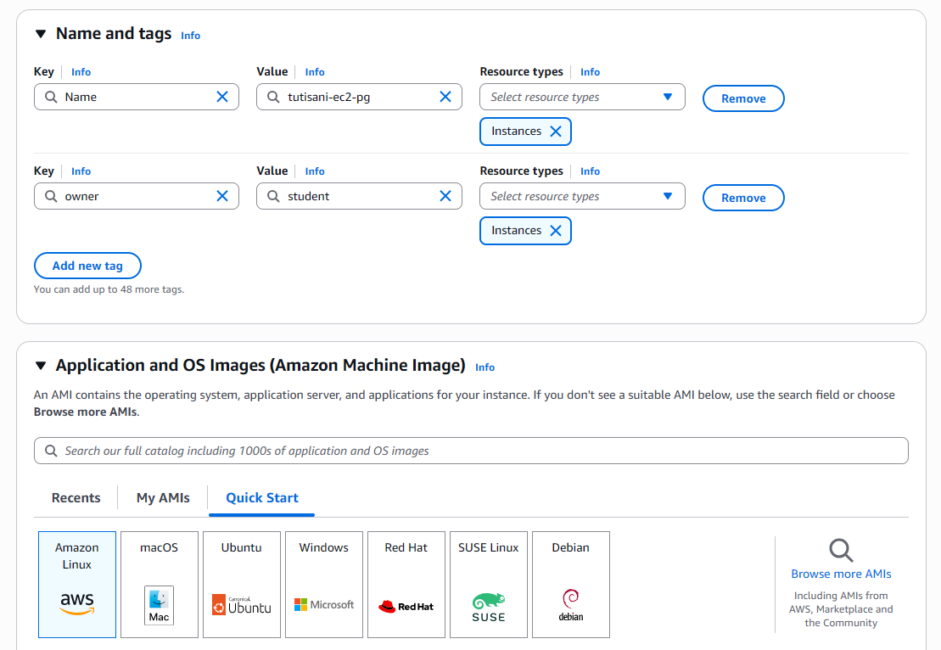
Figure 1. EC2 Instance Name, Tags, and AMI Selection

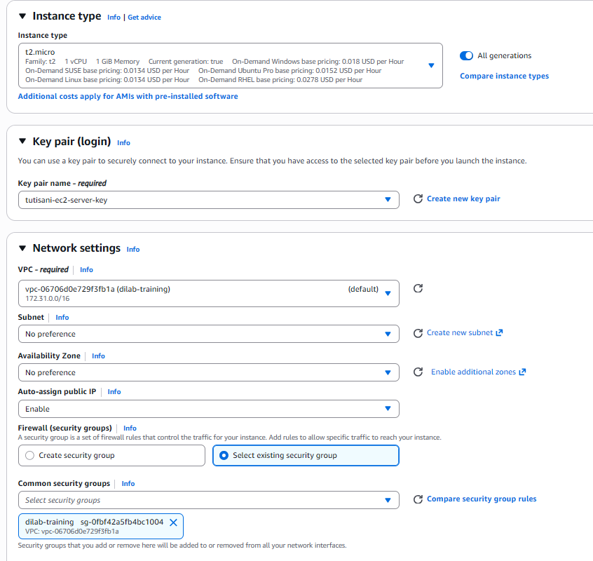
Figure 2. Instance type, Security Group
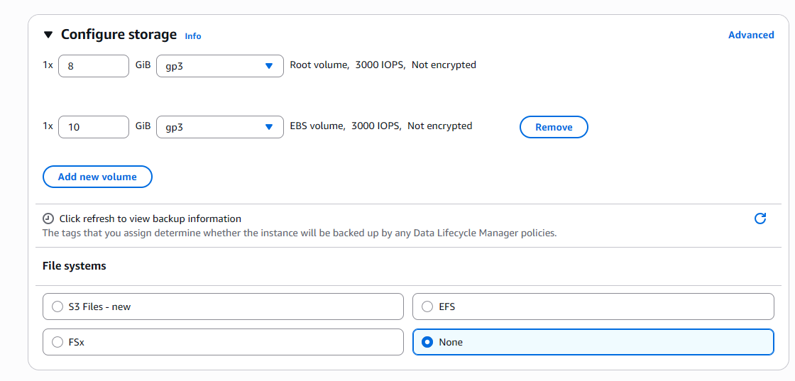
Figure 3. Storage Configuration
For networking, I attached the required dilab-training and dilab-training-new security groups, and under Advanced Details I attached the AWS_EC2_full_access_S3 IAM instance profile so the instance could interact with S3 without needing hardcoded credentials. I also made sure to set Metadata Accessible to Enabled and Metadata Version to "V2 only," satisfying the security requirement to enforce IMDSv2 (Figure 4). Before launching, I reviewed the full configuration summary to confirm everything was correct (Figure 5), then launched the instance and confirmed the successful launch notification (Figure 6).

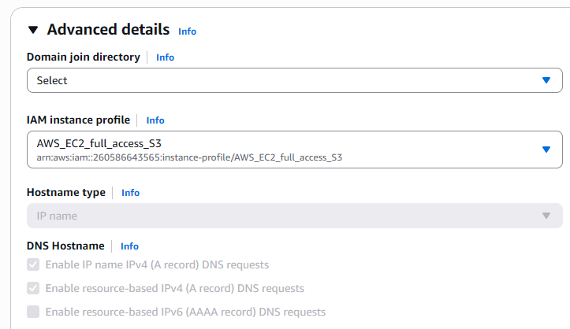
Figure 4. Advanced Details and IAM Instance Profile Configuration
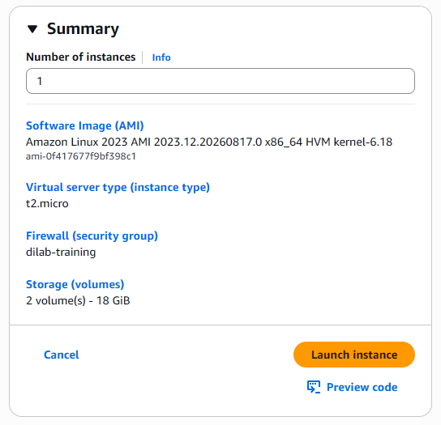
Figure 5. EC2 Instance Configuration Summary
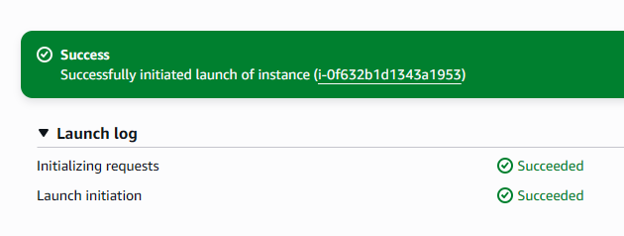
Figure 6. Successful EC2 Instance Launch Notification
Once the instance reached the "Running" state, I connected to it. I initially attempted EC2 Instance Connect through the browser, but ran into a SendSSHPublicKey failed error, so I switched to PuTTY instead. I used PuTTYgen to import the .pem key pair generated during instance launch and converted it into a .ppk private key file (Figure 7). I then configured PuTTY with the instance's public DNS and pointed it to the converted key file for authentication (Figure 8), which resulted in a successful SSH session into the instance (Figure 9).

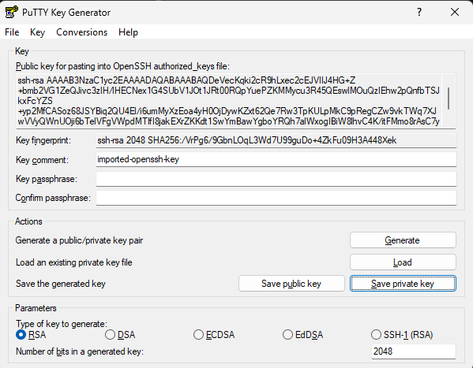
Figure 7. The imported key loaded in PuttyGen

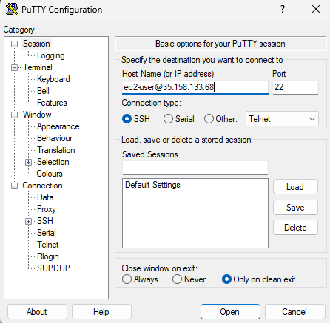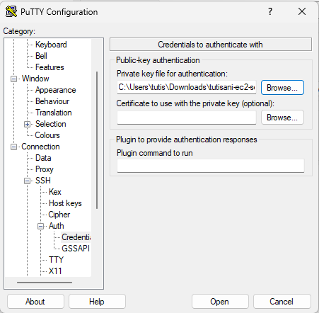
Figure 8. Configuring Putty
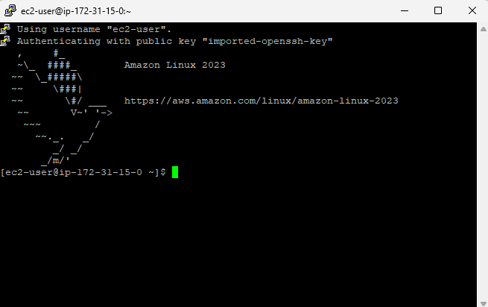
Figure 9. PuTTY terminal window showing the successful SSH login prompt
With terminal access established, I updated the package manager and installed PostgreSQL server (Figure 10). I initialized the database cluster with postgresql-setup --initdb, enabled the service to start on boot, and confirmed the service was active and running via systemctl status (Figure 11). I then logged into the PostgreSQL interactive terminal (psql) as the postgres superuser and set a password for remote authentication (Figure 12).
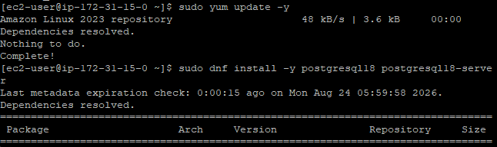
Figure 10. Updating Package Manager and Installing PostgreSQL 18 server
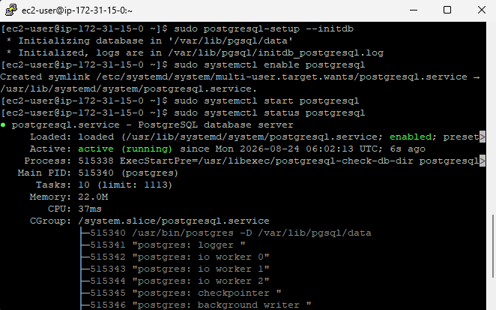
Figure 11. Initializing the PostgreSQL database cluster and verifying the running service status on AWS EC2
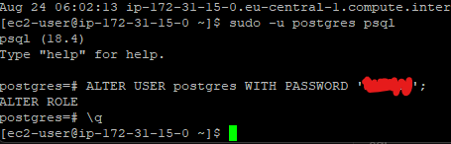
Figure 12. Configuring the superuser password inside the PostgreSQL interactive terminal (psql)

By default, PostgreSQL only listens on localhost, so to allow external connections from my Windows machine I edited two configuration files. First, I modified postgresql.conf and changed listen_addresses to '*' so the server would listen on all network interfaces (Figure 13). Second, I edited pg_hba.conf to add a rule allowing password-based (md5) authentication from any IP address (0.0.0.0/0), which is necessary for remote client tools like DBeaver to connect (Figure 14).

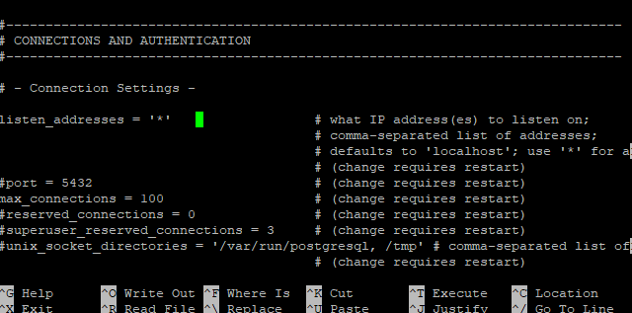
Figure 13. Modifying postgresql.conf to enable external connectivity by setting listen_addresses = '*'

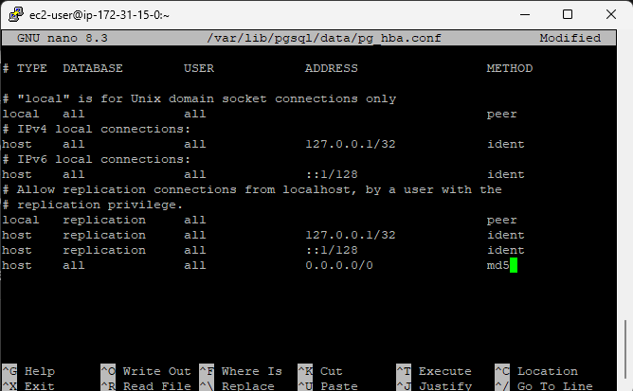
Figure 14. Configuring pg_hba.conf to allow remote client authentication via password (md5) from all IP addresses (0.0.0.0/0)

Using DBeaver on my Windows machine, I created a new PostgreSQL connection using the instance's public IP, port 5432, database postgres, username postgres, and the password I configured earlier. The connection tested successfully and I was able to browse the database structure directly from DBeaver (Figure 15).
Connection details for verification:
- Host: 35.158.133.68
- Port: 5432
- Database: postgres
- Username: postgres
- Password: [configured password]
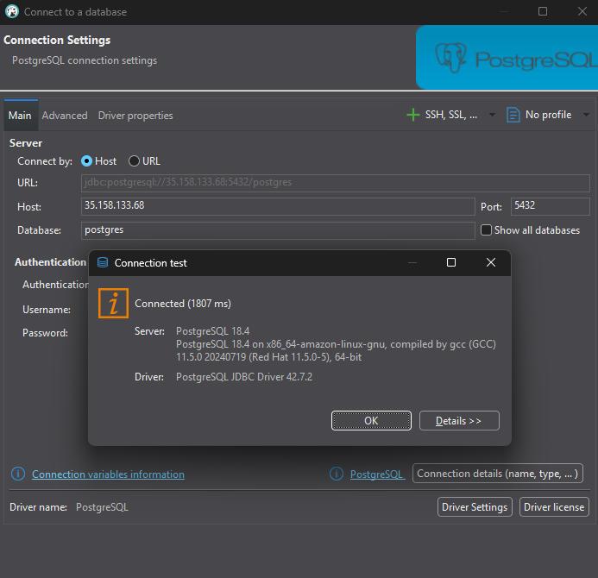
Figure 15. Successfully establishing a remote connection to the PostgreSQL database instance from DBeaver
Finally, to satisfy the requirement of creating database objects, I created a table, a view, and a procedure inside the database. I ran queries against the table and view to confirm the data was correctly inserted and retrievable (Figure 16), and I also inspected the column definitions of both the table and view to confirm the schema was set up as expected (Figure 17).

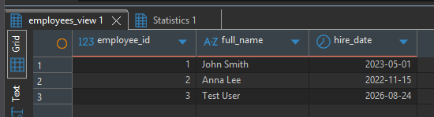
Figure 16. Querying table and view records
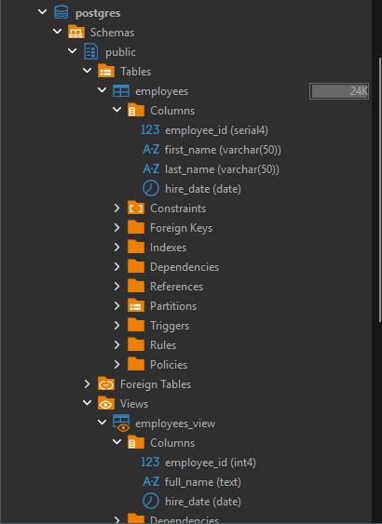

Figure 17. Inspecting table and view column definitions

Copying Data from S3 to EC2 Using the IAM Role
To demonstrate that the IAM role attached to the instance (AWS_EC2_full_access_S3) was working correctly, I ran aws s3 ls directly from the EC2 terminal without configuring any credentials manually. The command successfully listed my S3 buckets from Task 1, confirming the role was granting the instance the necessary permissions (Figure 18).
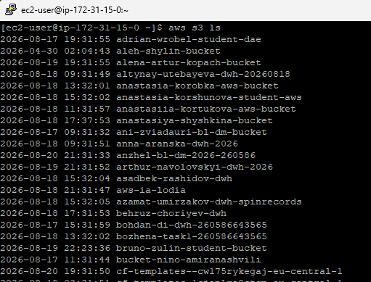
Figure 18. Listing AWS S3 buckets from the EC2 command line to verify data storage integration
I then used aws s3 cp to copy a sales fact data file from my tamar-tutisani-epam-lab bucket down to the local EC2 instance directory. After the copy completed, I listed the directory contents to confirm the file had downloaded successfully (Figure 19), and I also opened the file directly in the terminal to inspect the raw CSV records (Figure 25).
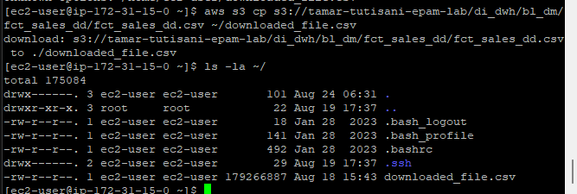
Figure 19. Copying sales fact data from the S3 data warehouse bucket (tamar-tutisani-epam-lab) to the local EC2 instance directory and verifying file download details

Creating a Snapshot and Custom AMI
Next, I created a backup of the instance's storage. I navigated to the EBS Volumes section, selected the 10GB secondary volume attached to my instance, and configured the snapshot with a descriptive name and the owner=student tag (Figure 20). Once the snapshot completed, AWS confirmed its successful creation (Figure 21).
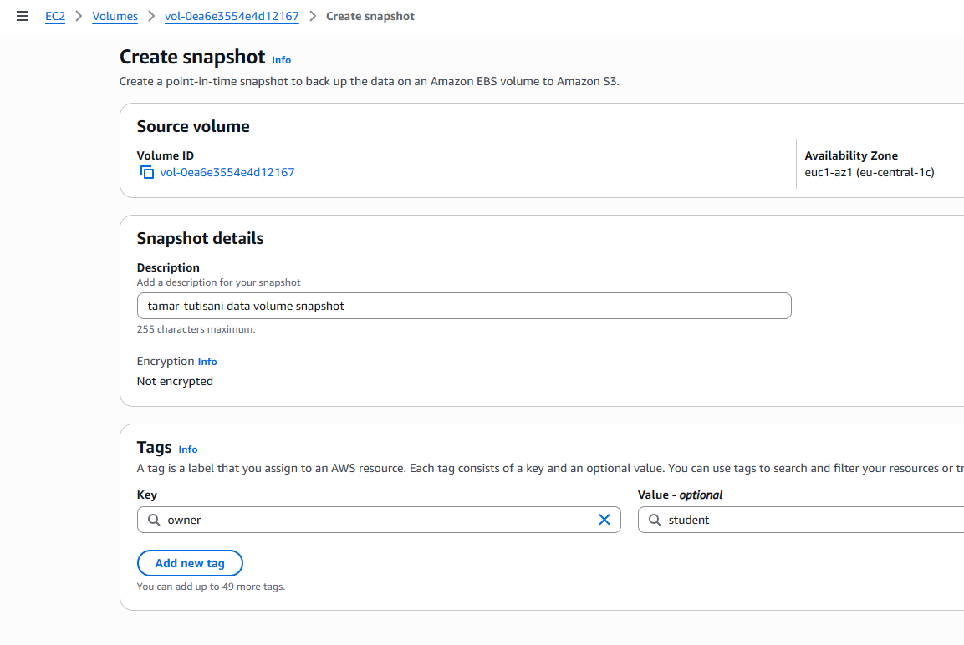
Figure 20. Configuring volume details and tags to create an snapshot from the EC2 instance storage

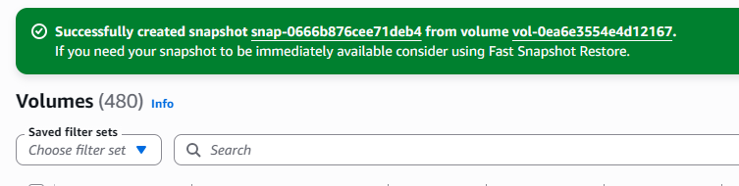
Figure 21. Confirmation message showing the successful creation of the snapshot
Using this snapshot, I then created a custom Amazon Machine Image (AMI), giving it an identifiable name so it could be easily recognized later (Figure 22). After a short wait, the AMI's status changed to "available," confirming it was ready to use for launching new instances (Figure 23).
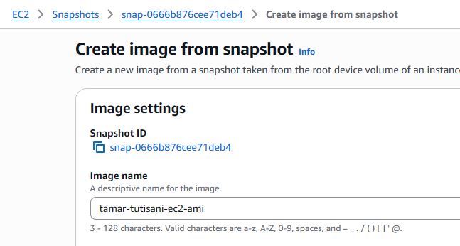
Figure 22. Setting up the image configuration parameters to create a custom Amazon Machine Image (AMI)

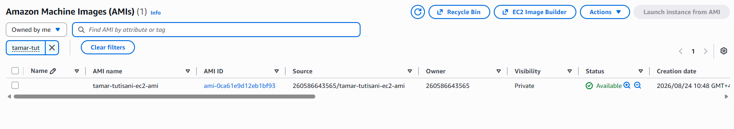
Figure 23. Viewing the successfully created and available custom AMI

Launching a New Instance from the AMI
To verify that the AMI correctly preserved the state of my original instance, I launched a brand-new EC2 instance directly from the custom AMI. I named it tutisani-ec2-pg-copy, kept the same t2.micro instance type, reused the same key pair, and attached the same dilab-training and dilab-training-new security groups. I also made sure to re-enable Metadata V2-only again, since this setting does not carry over automatically from the AMI (Figure 24).
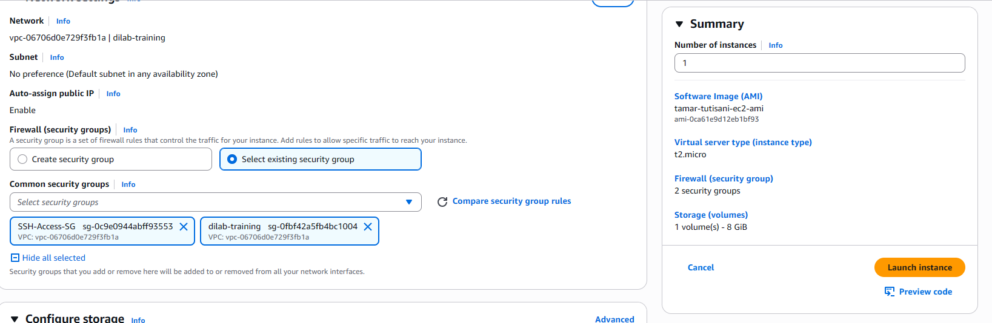
Figure 24. Instance Summary

Once the new instance was running, I connected to it via SSH and checked whether the sales data file I had downloaded in Step 2 was still present. It was, confirming that the AMI had successfully captured and restored the full state of the original instance, including the data files copied from S3.
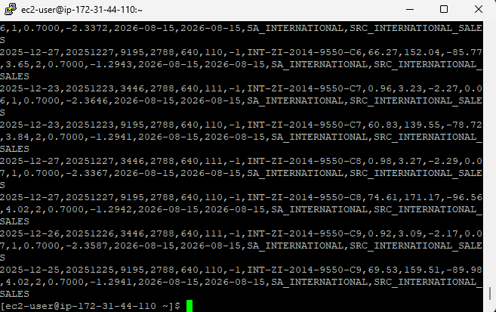
Figure 25. Viewing raw sales CSV records in the EC2 terminal

Deploying an Apache Web Server
To complete the web server requirement, I installed Apache (httpd) on the instance, enabled it to start on boot, and started the service. I verified it was active and running using systemctl status (Figure 26).
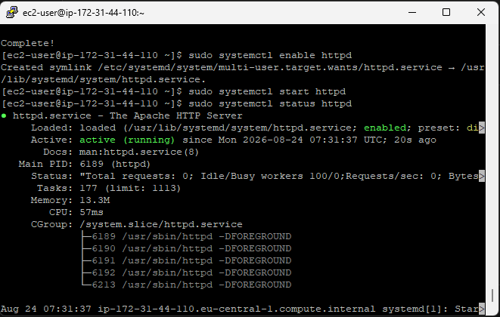
Figure 26. Starting and verifying the Apache HTTP Server (httpd) status
I then edited the default index.html file inside /var/www/html using the nano text editor and wrote a simple custom greeting page (Figure 27). After restarting Apache I opened a browser and navigated to the instance's public IP address. The custom page rendered correctly, confirming the web server was properly configured and publicly accessible (Figure 28).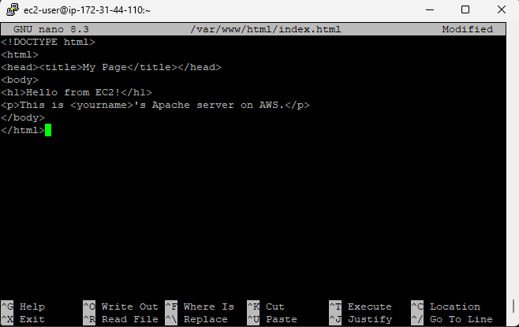
Figure 27. Editing the index.html file in GNU nano

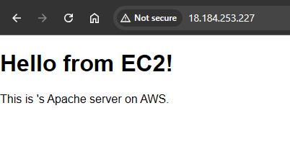
Figure 28. Rendering the custom Apache greeting page via the public IP

CloudWatch Alarm and SNS Email Notifications
To set up monitoring and alerting, I first created an SNS topic named tamar-tutisani-ec2-alerts (Figure 29). I subscribed my email address to this topic and received a confirmation email from AWS, which I accepted (Figure 30). After confirming, the subscription status changed to "Confirmed" in the SNS console (Figure 31).

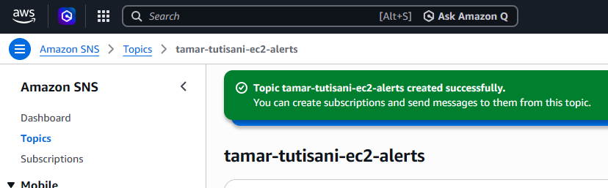
Figure 29. Creating the tamar-tutisani-ec2-alerts SNS topic
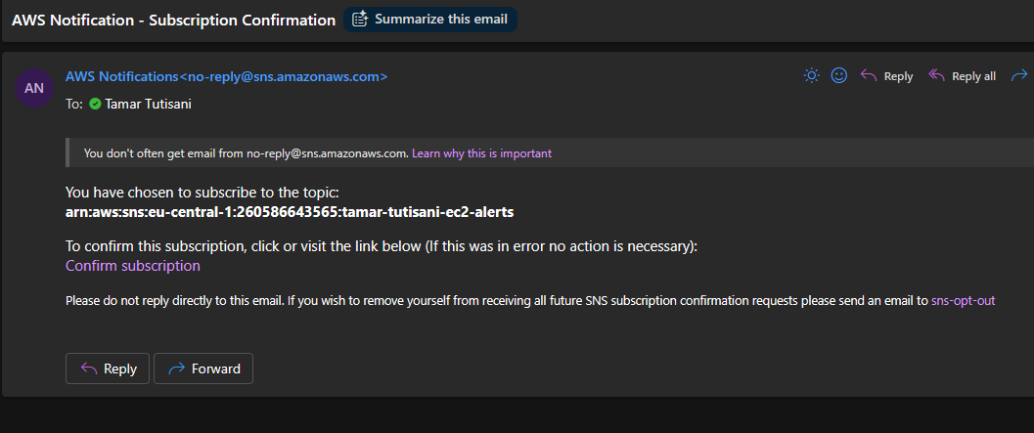
Figure 30. AWS subscription confirmation email
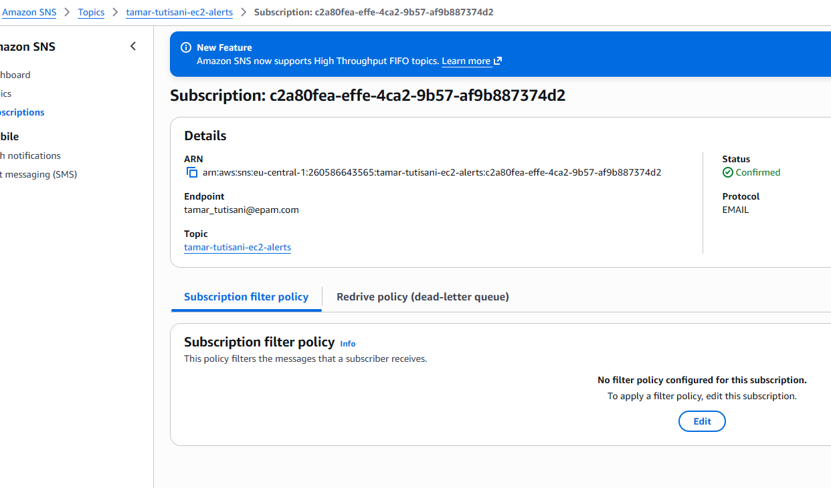
Figure 31. Amazon SNS subscription confirmation status
Next, I moved to CloudWatch to create an alarm. I first generated a metric graph for my EC2 instance's CPUUtilization to see its typical behavior (Figure 32), then selected this specific metric from the browser list to build the alarm around it (Figure 33). I configured a static threshold condition so the alarm would trigger if CPU usage exceeded a sensible level over a defined evaluation period (Figure 34).
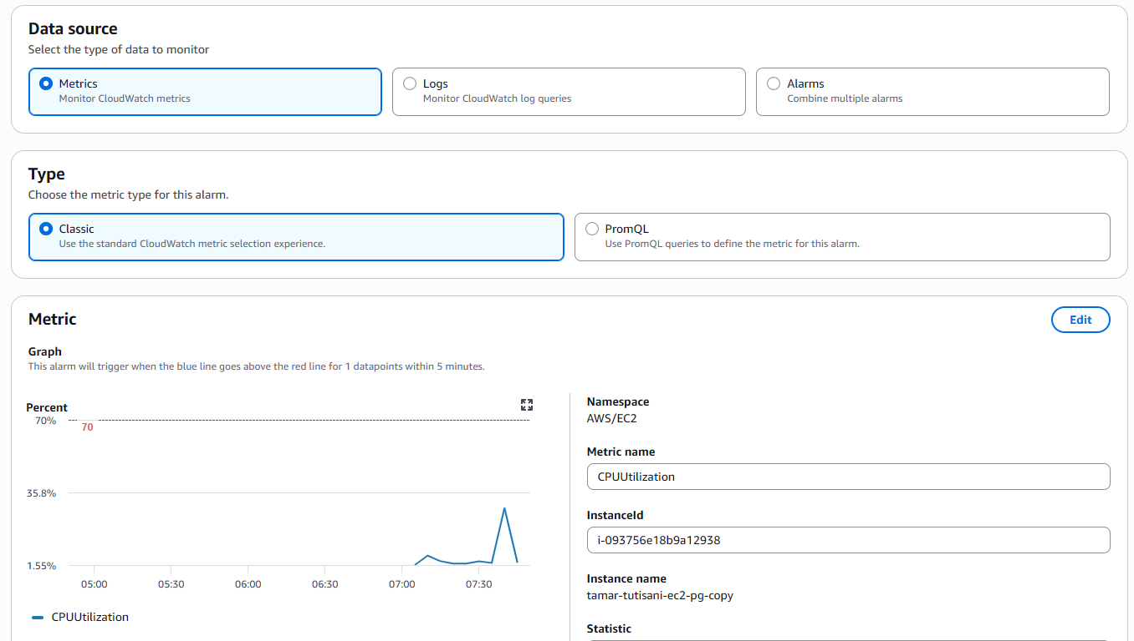
Figure 32. Creating the CPUUtilization metric graph for the EC2 instance

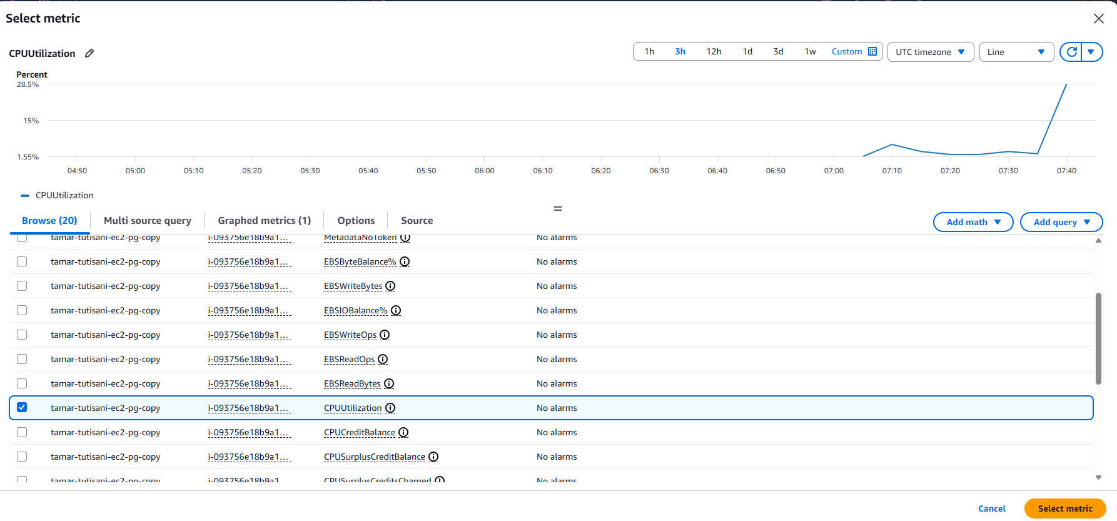
Figure 33. Selecting the CPUUtilization metric from the browser list for the instance
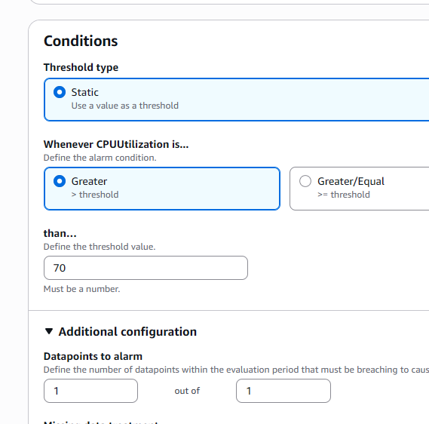
Figure 34. Configuring the static threshold condition
For the alarm's action, I configured it to notify my previously created SNS topic, tamar-tutisani-ec2-alerts, whenever the alarm entered an "in alarm" state (Figure 35). I reviewed the full configuration before finalizing the alarm, named tamar-tutisani-ec2-cpu-alarm (Figure 36). After creation, I checked the alarm's dashboard and confirmed it was actively monitoring the instance and currently showing an "OK" status, meaning CPU usage was within the normal threshold (Figure 37).
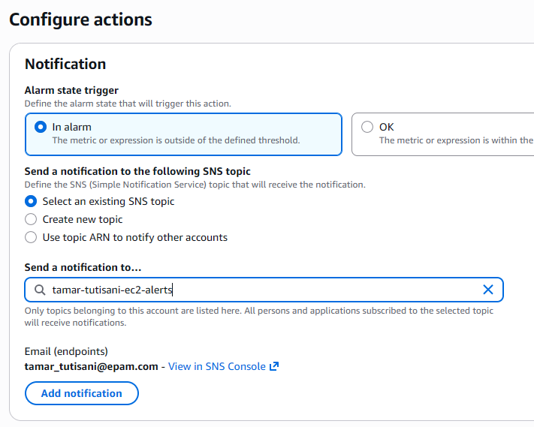
Figure 35. Configuring CloudWatch alarm actions to notify the tamar-tutisani-ec2-alerts SNS topic

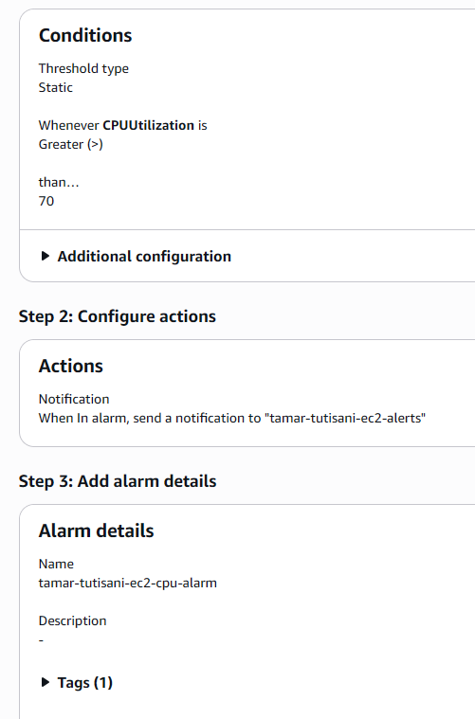
Figure 36. Reviewing the configuration details for tamar-tutisani-ec2-cpu-alarm

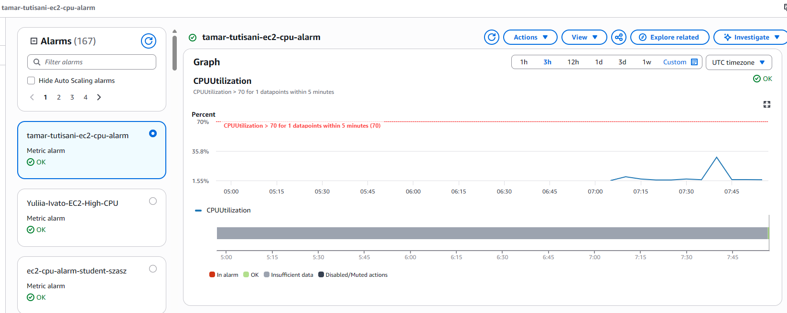
Figure 37. Viewing the active dashboard for the alarm showing an OK status

Infrastructure as Code with CloudFormation
To recreate the EC2 instance using Infrastructure as Code, I wrote a CloudFormation YAML template defining an EC2 instance with the same key properties as my manually created instance: t2.micro instance type, the dilab-training security group, the owner=student tag, and MetadataOptions configured to require IMDSv2 tokens (matching the security requirement from Step 1).
Before writing the template, I looked up the current Amazon Linux 2023 AMI ID for the eu-central-1 region directly from the EC2 launch wizard to ensure the template referenced a valid, up-to-date image (Figure 41).
AWSTemplateFormatVersion: '2010-09-09'
Description: EC2 instance for Task 2 - CloudFormation version

Parameters:
KeyName:
Type: AWS::EC2::KeyPair::KeyName
Description: Existing EC2 KeyPair

Resources:
MyEC2Instance:
Type: AWS::EC2::Instance
Properties:
InstanceType: t2.micro
ImageId: ami-0eddb4a4e7d846d6f # replace with a current Amazon Linux 2023 AMI ID for eu-central-1
KeyName: !Ref KeyName
SecurityGroups:
- dilab-training
MetadataOptions:
HttpTokens: required # enforces IMDSv2 only
HttpEndpoint: enabled
Tags:
- Key: owner
Value: student
- Key: Name
Value: yourname-cf-ec2

Outputs:
InstanceId:
Value: !Ref MyEC2Instance
PublicIP:
Value: !GetAtt MyEC2Instance.PublicIp

I deployed this template through the CloudFormation console, creating a new stack named tamar-tutisani-ec2-stack. I reviewed the stack's configuration and resource details before submitting (Figure 38), and monitored the stack's events until it reached the CREATE_COMPLETE status, confirming the EC2 instance had been successfully provisioned entirely through code (Figure 39).
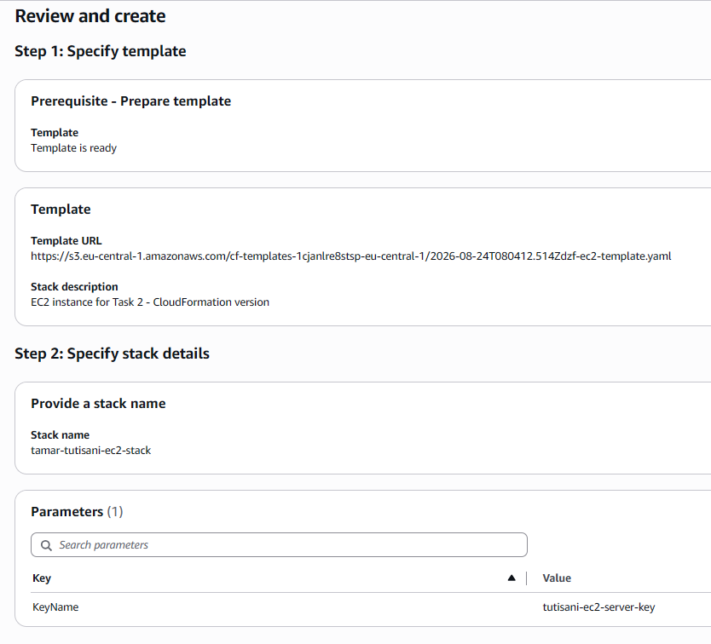
Figure 38. Reviewing CloudFormation template settings and stack details for tamar-tutisani-ec2-stack
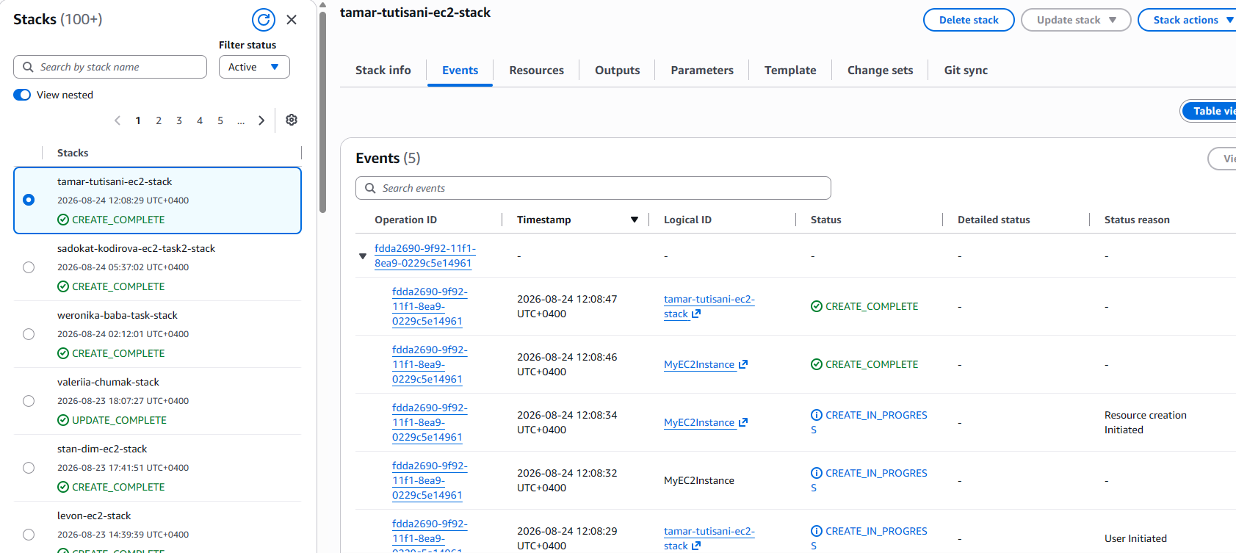
Figure 39. Monitoring events showing the CREATE_COMPLETE status for tamar-tutisani-ec2-stack
I initially attempted to upload the template file to my S3 bucket using the AWS CLI, but ran into an "Unable to locate credentials" error, followed by an AccessDenied error even after configuring an SSO profile — it turned out my assumed role did not have s3:PutObject permissions via CLI in that context. As a workaround, I uploaded the ec2-template.yaml file directly through the S3 console instead, which completed successfully (Figure 40).
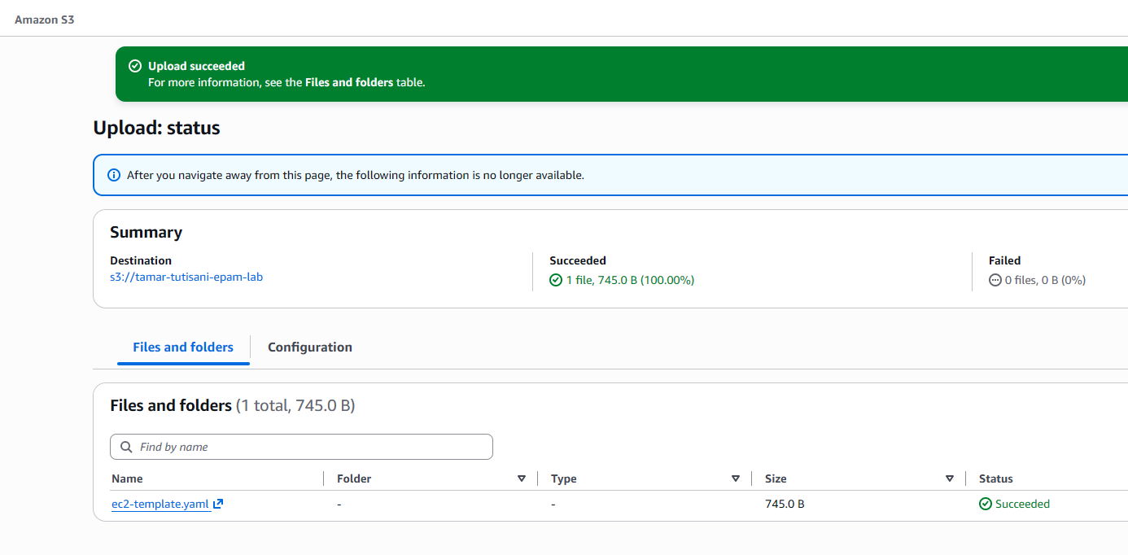
Figure 40. Confirming the successful upload of ec2-template.yaml to the tamar-tutisani-epam-lab S3 bucket

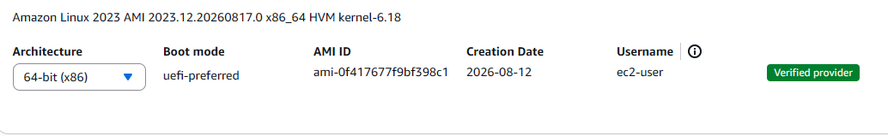
Figure 41. Finding ID of the Amazon Linux 2023 AMI

Dockerized Database Service with Scheduled Automation
I installed Docker on the EC2 instance and started the Docker service (Figure 42). I then pulled the official PostgreSQL image and ran it as a container named pg-docker, mapping it to a separate port so it could run independently of the PostgreSQL installation from Step 1 (Figure 43).
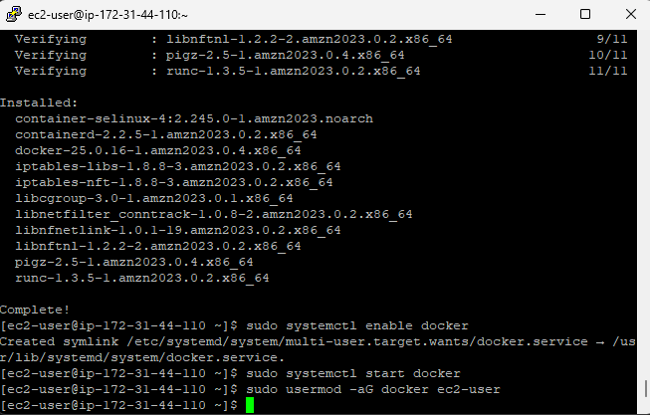
Figure 42. Installing container services and starting Docker on the EC2 instance
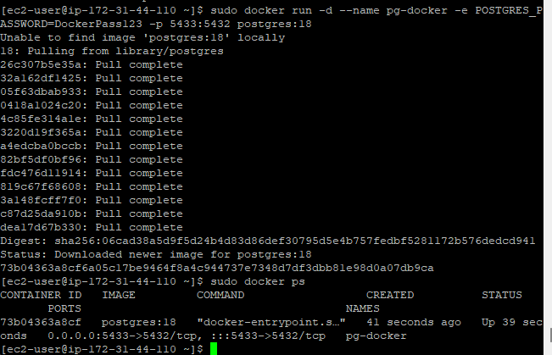
Figure 43. Pulling the PostgreSQL image and running the pg-docker container
To demonstrate scheduled automation against this containerized service, I wrote a small shell script, check_db.sh, which uses docker exec to run a simple SELECT NOW(); query against the PostgreSQL container and appends the timestamped result to a log file (Figure 44).
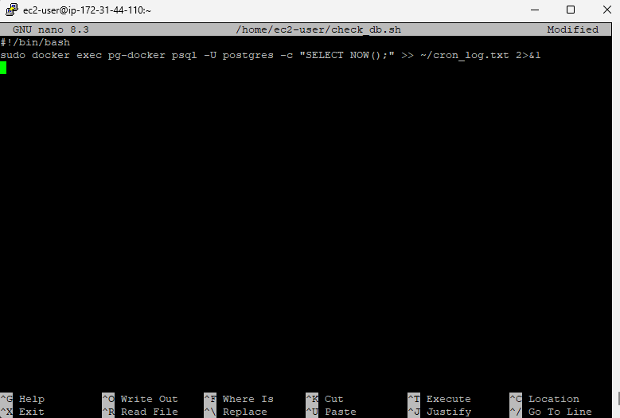
Figure 44. Creating the check_db.sh script to execute a PostgreSQL timestamp query via Docker
I installed and enabled the crond service, then added a cron job to run this script automatically every 5 minutes (Figure 45). After letting it run for a period of time, I tested the script manually and inspected cron_log.txt, which showed multiple timestamped entries confirming the cron job had executed successfully and repeatedly against the Dockerized database service (Figure 46).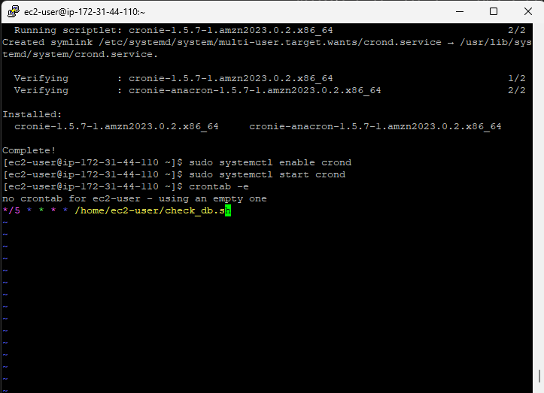
Figure 45. Installing and enabling crond, and setting up a cron job to run the script every 5 minutes.
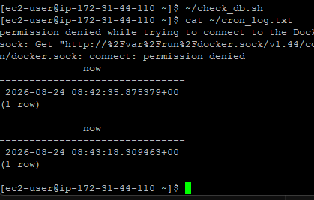
Figure 46. Testing check_db.sh and viewing successfully logged database timestamps in cron_log.txt

Conclusion
Through this task, I provisioned and configured a complete EC2-based database environment from the ground up, installing and securing PostgreSQL, integrating with S3 via IAM roles, implementing backup and recovery through snapshots and AMIs, deploying a public-facing web server, setting up proactive monitoring and alerting, codifying the infrastructure with CloudFormation, and extending the setup with a containerized service running on an automated schedule. All resources were properly tagged and, per the task instructions, were stopped after each testing session to avoid unnecessary costs.

